**Week-1**

**Design Patterns and Principles**

**HandsOn**

**Exercise 1: Implementing the Singleton Pattern**

**Scenario:**

You need to ensure that a logging utility class in your application has only one instance throughout the application lifecycle to ensure consistent logging.

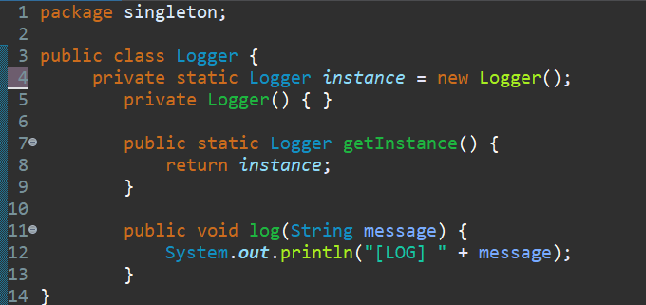**class Logger:**

**class SingletonTest:**

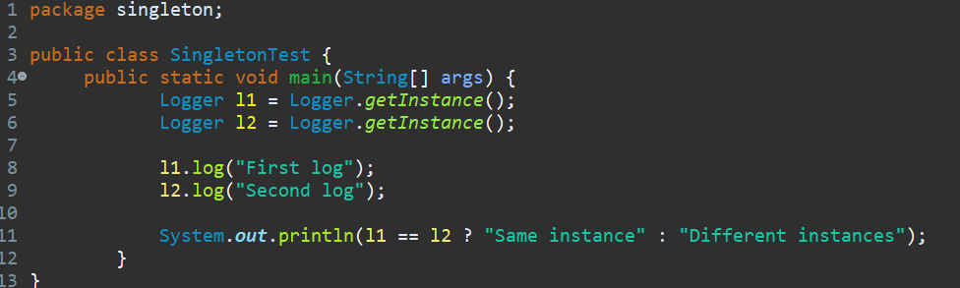

**Output:**

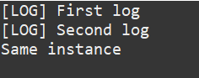

**Exercise 2: Implementing the Factory Method Pattern**

**Scenario:**

You are developing a document management system that needs to create different types of documents (e.g., Word, PDF, Excel). Use the Factory Method Pattern to achieve this.

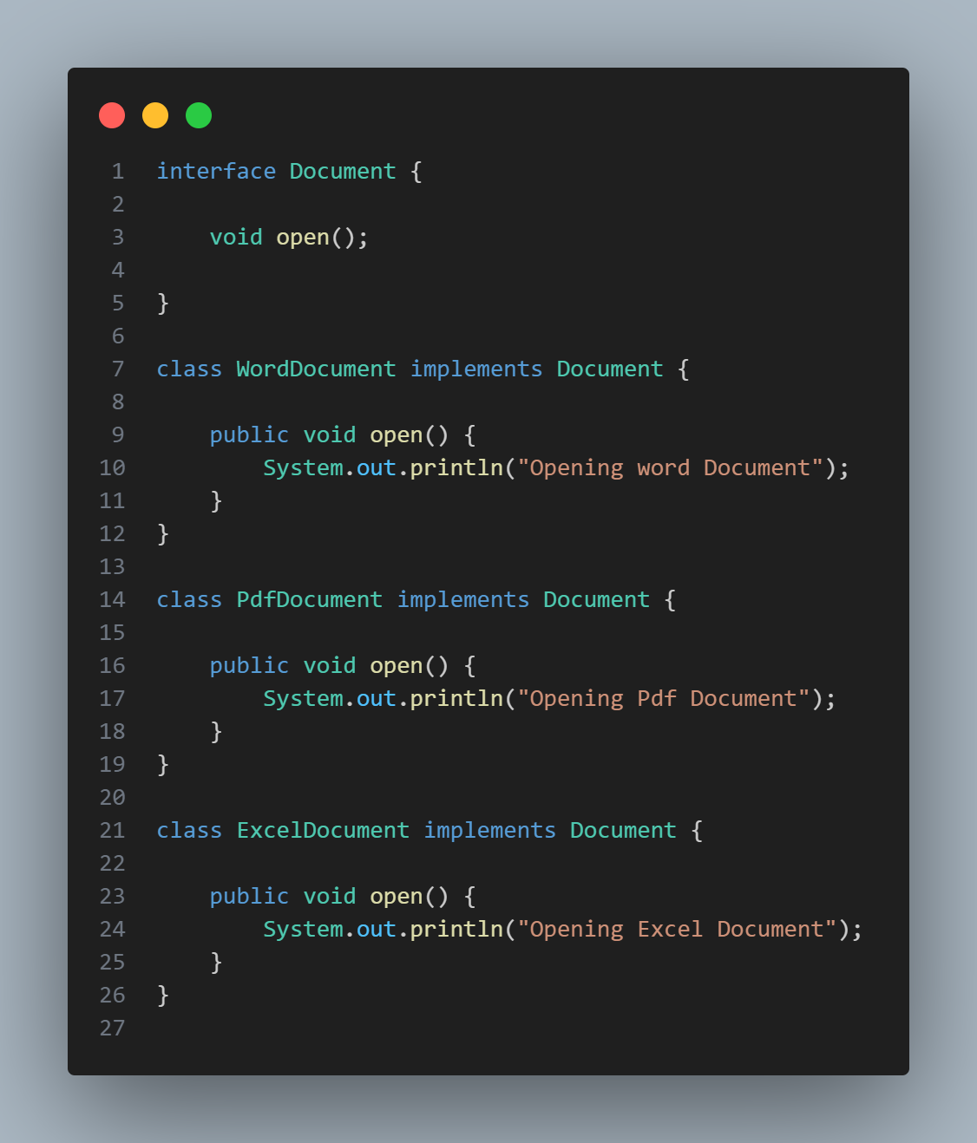

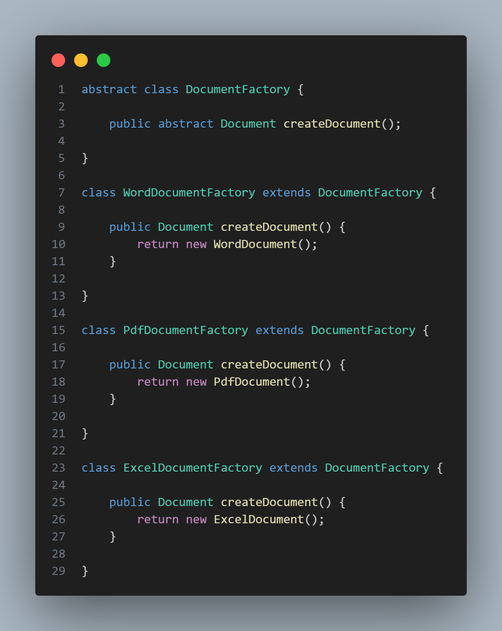

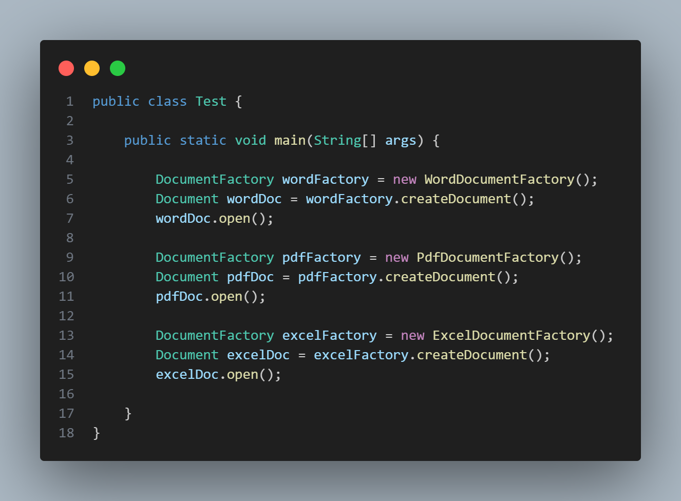

**Output:**

